1. Open “Customer Churn.csv” file using SPSS Statistics

2. Recode «Dependents» variable into new dummy variable. (No-0, Yes-1).

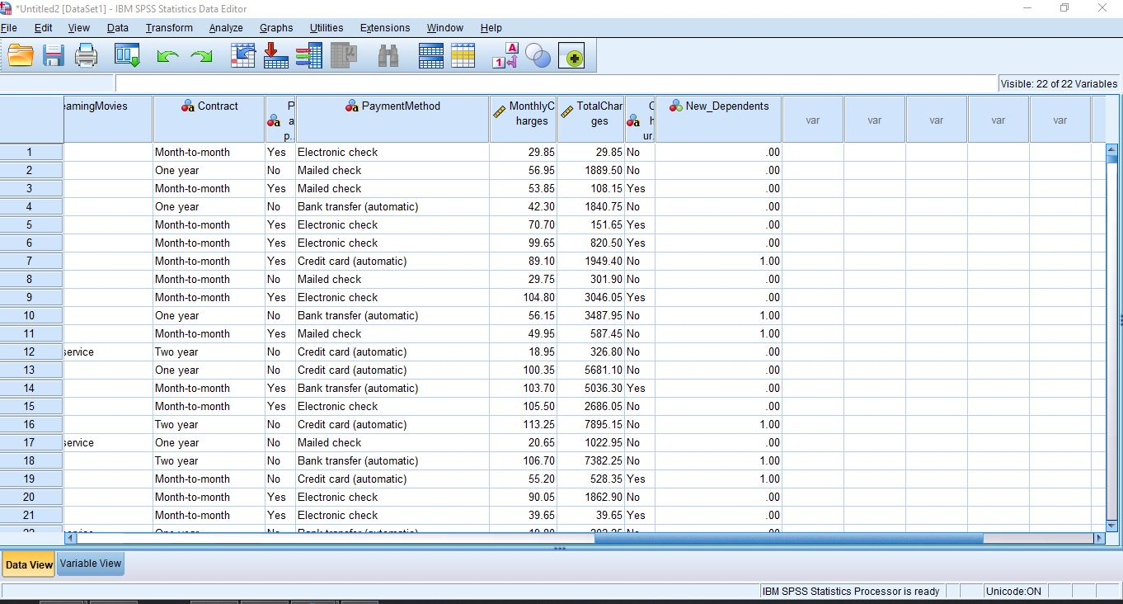

3. Find outliers using numerical (Z Score) and graphical method (box-plot) for “TotalCharges” and “MonthlyCharges” variables.

Find outliers using numerical (Z Score) for “MonthlyCharges” variables.

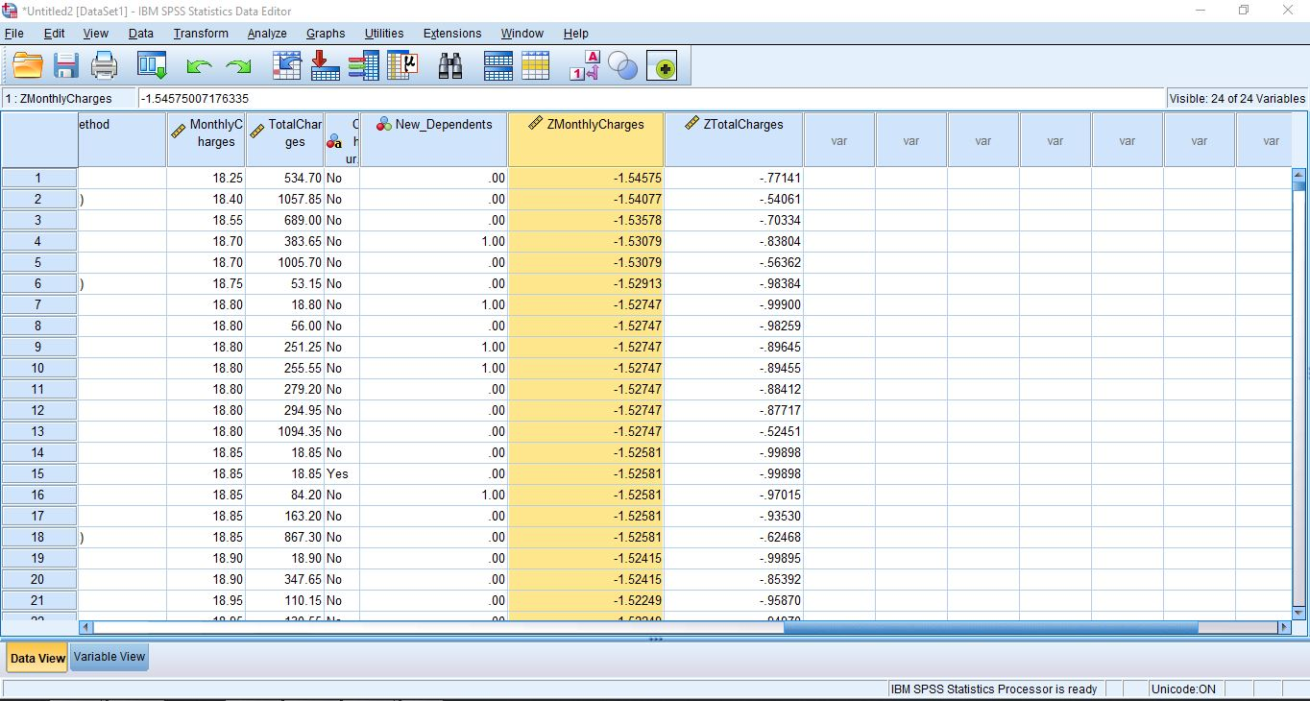

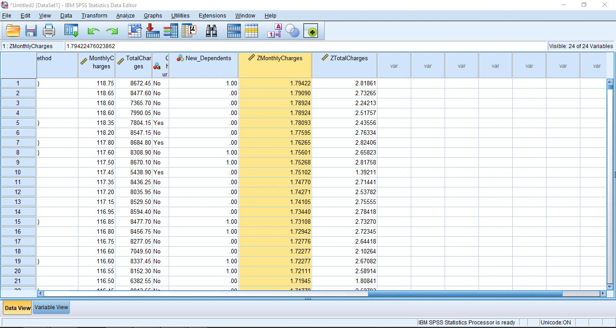

Find outliers using numerical (Z Score) for “TotalCharges” variables.

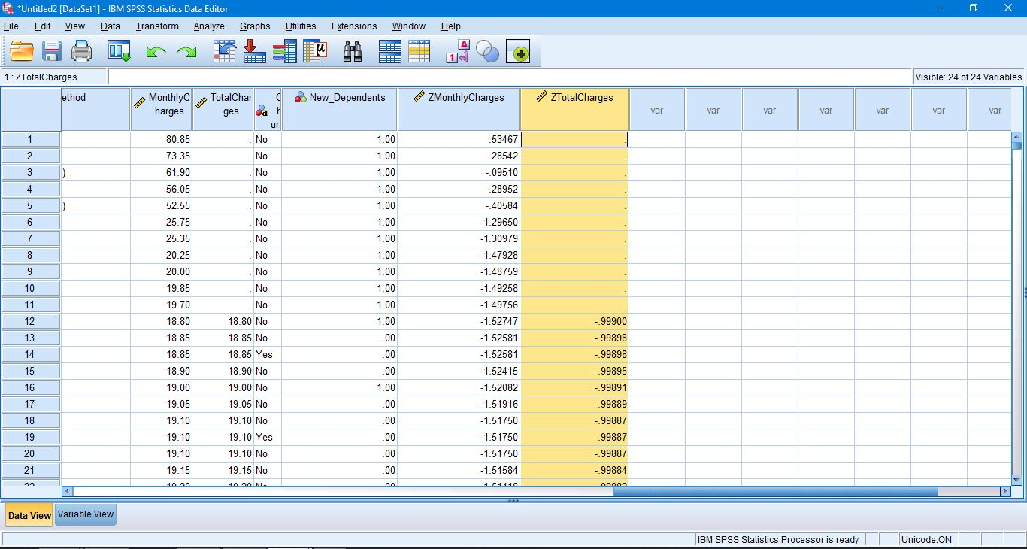

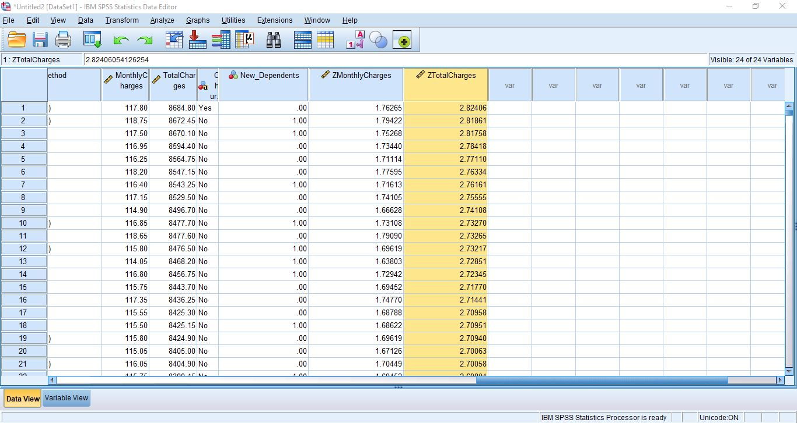

Find outliers using graphical method (box-plot) for “MonthlyCharges” variables.

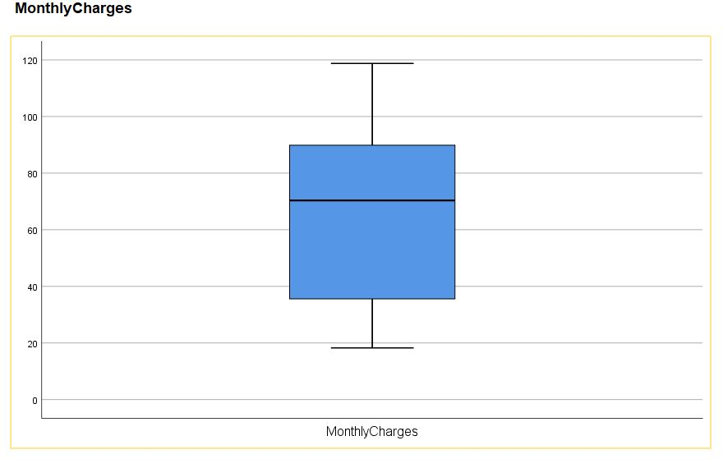

Find outliers using graphical method (box-plot) for “TotalCharges” variables.

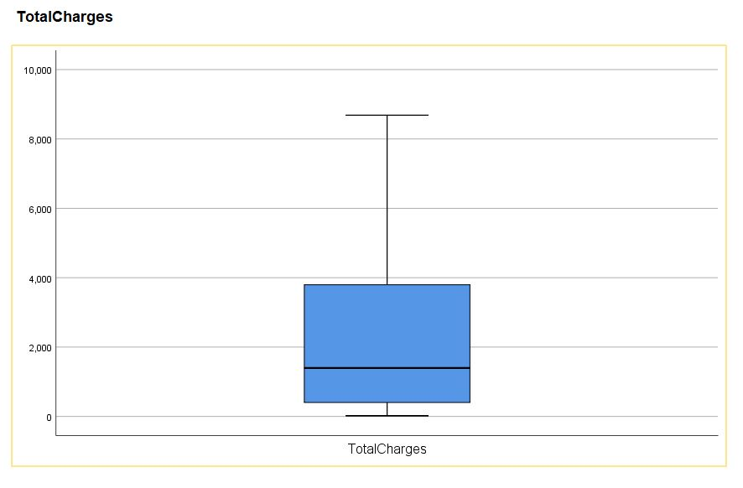

4. Transform “Monthly Charges” variable into 5 groups.

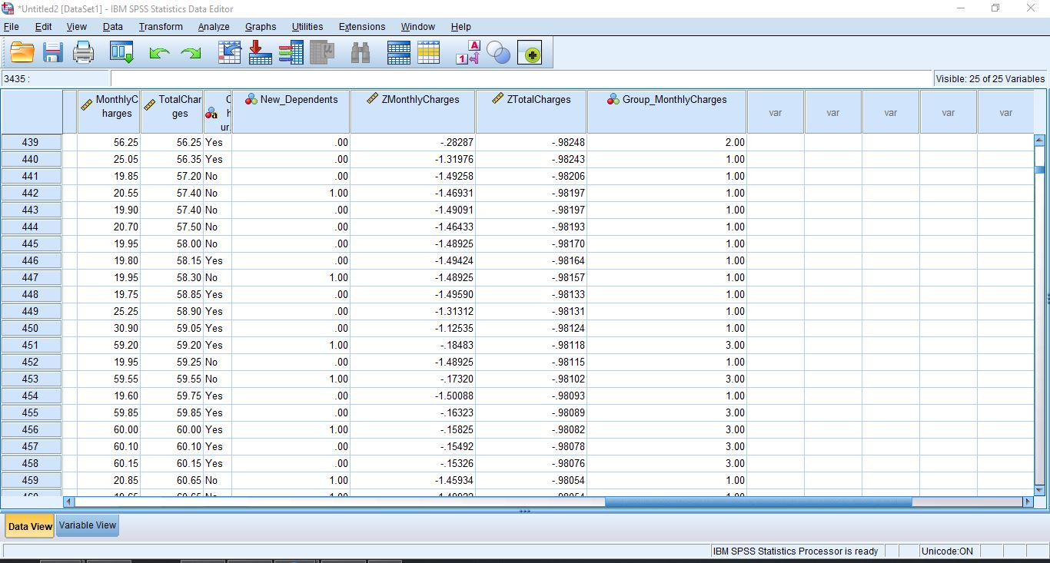

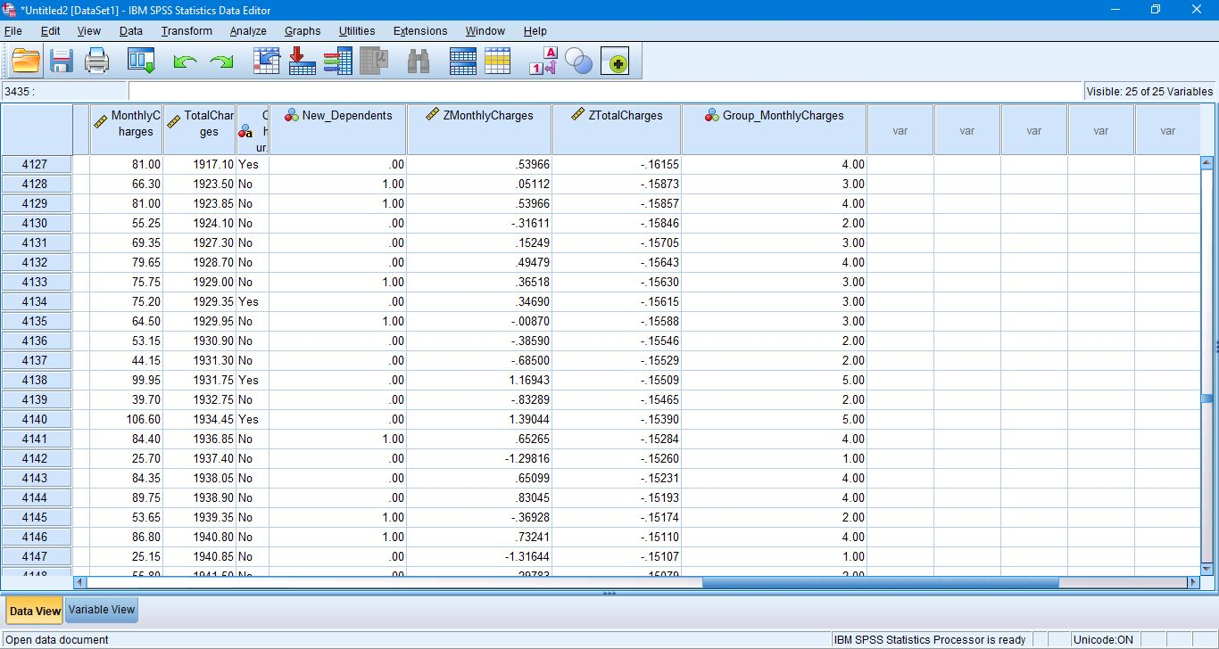

5. Compute mean, median, mode, quartiles, minimum and maximum of all numerical variables in dataset.

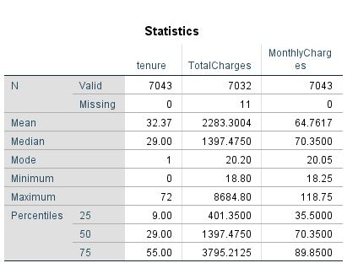

6. Import “bankloan.sav” file from Demos into SPSS Modeler.

7. Explore “bankloan.sav” data.

